Ideation Phase

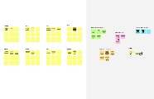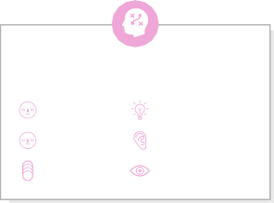

**Brainstorm & Idea Prioritization Template**

|  |  |
| --- | --- |
| Team ID | LTVIP2023TMID07965 |
| Project Name | Classification of arrhythmia by using deep learning with 2-d ecg spectral image representation |
| Maximum Marks | 4 Marks |

Step-1: Team Gathering, Collaboration and Select the Problem Statement

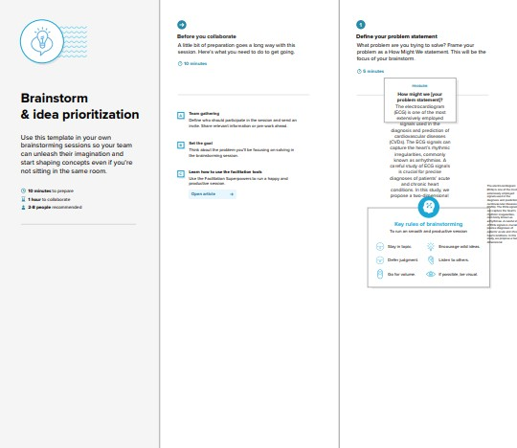

Step-2: Brainstorm, Idea Listing and Grouping

Step-3: Idea Prioritization

